## SQL SCRIPT

1. Problem:- A list of products with a base price greater than 500 and that are featured in promo type of ‘BOGOF’ (Buy One Get One Free).

Solution:-

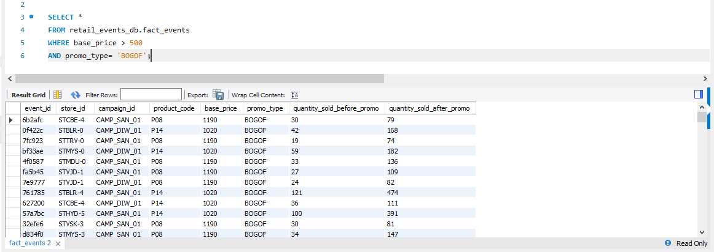

1. Problem:- A report that provides an overview of the number of store in each city. The result will be sorted in descending order of store counts, allowing the identification of cities with highest store presence.

Solution:-

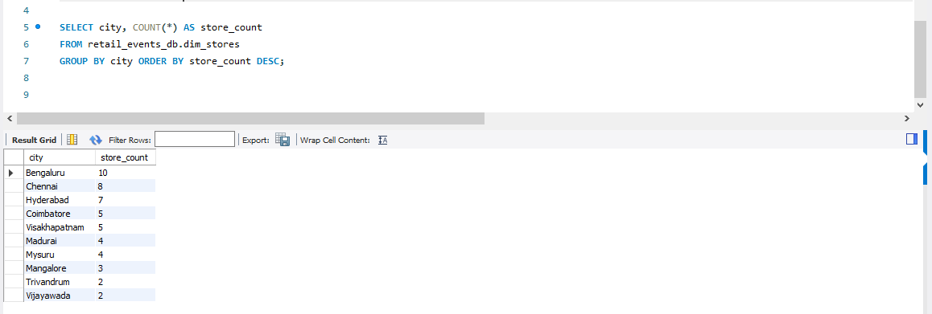

1. Problem:- A report that displays each campaigns along with the total revenue generated before and after the campaign. (Display the values in millions).

Solution:-

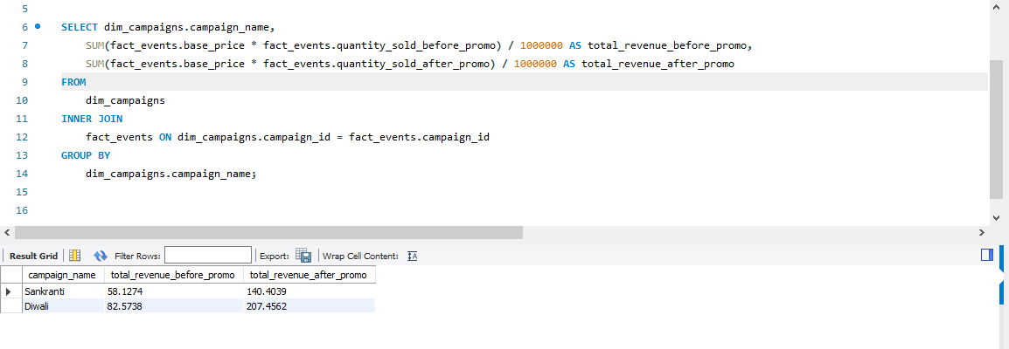

1. Problem:- A report that calculates the Incremental Sold Quantity(ISU%) for each category during the Diwali campaign. Additionally, provide rankings for the categories based on their ISU%.

Solution:-

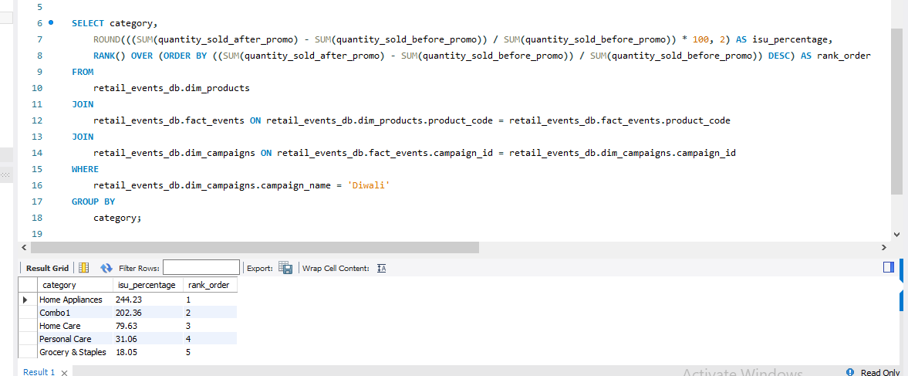

1. Problem:- A report featuring the top 5 products, ranked by Incremental Revenue Percentage (IR%) across all campaigns.

Solution:-

